|  |  |
| --- | --- |
| **Logical problems** | |
| **1)** |  |
|  | **Write a program that reads a number from the user and finds the result of multiplying the first digit by itself as many times as the last digit of the number.** |
|  | **Example:-**  **Input = 247**  **Output = 2*2*2*2*2*2*2 = 128** |
| **2)** |  |
|  | **Write a program that reads an integer number from the user and prints the number in words. Each digit of the number should be converted into its corresponding word.** |
|  | **Example:-**  **Input = 504**  **Output = Five Zero Four** |
| **3)** |  |
|  | **Write a program that reads an array of integers and finds the subarray whose sum is maximum. The program should display the subarray and the maximum sum.** |
|  | **Example:-**  **Input = [−2, 1, −3, 4, −1, 2, 1, −5, 4]**  **Output = 4 + (−1) + 2 + 1 = 6** |
| **4)** |  |
|  | **Write a program that performs Binary Search using a loop and recursion.**  **The program should return the index of the searched element if found, otherwise return -1.** |
|  | **Example:-**  **Input:**  **Array = [10, 20, 30, 40, 50] Search = 40**  **Output:**  **40 found at index 3** |
| **5)** |  |
|  | **Write a program that reads a number n from the user and calculates the sum of the series:**  **1 + (1+2) + (1+2+3) + … + (1+2+3+…+n)**  **Each term is the sum of numbers from 1 to k, where k goes from 1 to n.**  **The program should display the final total.** |
|  | **Example:-**  **Input = 4** |

|  |  |
| --- | --- |
|  | **Terms: 1**  **(1 + 2)**  **(1 + 2 + 3)**  **(1 + 2 + 3 + 4)**  **Output = 1 + 3 + 6 + 10 = 20** |
| **6)** |  |
|  | **Write a program that reads a small sentence (string) from the user and counts the number of vowels in it.**  **Consider vowels as: a, e, i, o, u (both uppercase and lowercase if needed).**  **The program should display the total count of vowels.** |
|  | **Example:-**  **Input = "hello world" Vowels = e, o, o**  **Output = 3** |
| **7)** |  |
|  | **Write a program that reads two 2D matrices from the user and performs matrix multiplication.**  **The program should display the resultant matrix after multiplication** |
|  | **Example:-**  **Input:**  **Matrix A (2×2)**  **1 2**  **3 4**  **Matrix B (2×2)**  **5 6**  **7 8**  **Output:**  **Resultant Matrix =**  **19 22**  **43 50** |
| **8)** |  |

|  |  |
| --- | --- |
|  |  |
| **9)** | **Given the number of rows and columns, print the corresponding swastika pattern using loops. Note: The number of rows and columns should be the same and an odd number. This will generate a perfect swastika pattern**  **.** |
| **10)** | **Implement a following pattern** |
| **Ex.10** | **Implement following pattern in java-script.** |
| **Ex.10-2** | **Implement following pattern in java-script. (Hallowrectangle)** |
|  | **Javascript problems** |
| **11)** | **Write a program to check whether a given string is a palindrome or not in javascript.**  **A string is called a palindrome if it reads the same forward and backward (ignoring case and spaces if needed).** |
|  | **Example:-**  **Input = "level"**  **Reverse = "level"**  **Output = Palindrome** |
| **12)** | **Write a JavaScript program that reads a sentence from the user and capitalizes the first letter of each word in the sentence.** |

|  |  |
| --- | --- |
|  | **The program should display the updated sentence where every word begins with an uppercase letter.** |
|  | **Example:-**  **Input = "hello world from js"**  **Output = Hello World From Js** |
|  |  |
| **13)** | **Write a JavaScript program to reverse an array.**  **The program should read an array of numbers (or strings) and display the array in reverse order.** |
|  | **Example:-**  **Input = [10, 20, 30, 40, 50]**  **Output = [50, 40, 30, 20, 10]** |
| **14)** | **Write a JavaScript program to reverse a string.**  **The program should read a string from the user and display the string in reverse order.** |
|  | **Example:-**  **Input = "hello"**  **Output = "olleh"** |
|  | **HTML & CSS Problems** |
| **15)** |  |
|  |  |

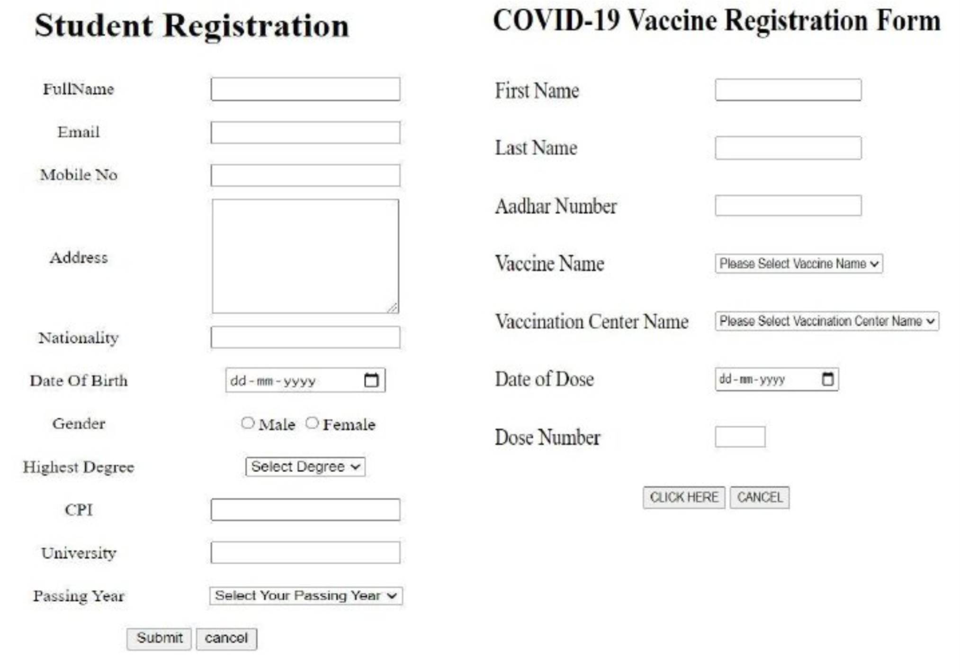

**17)**

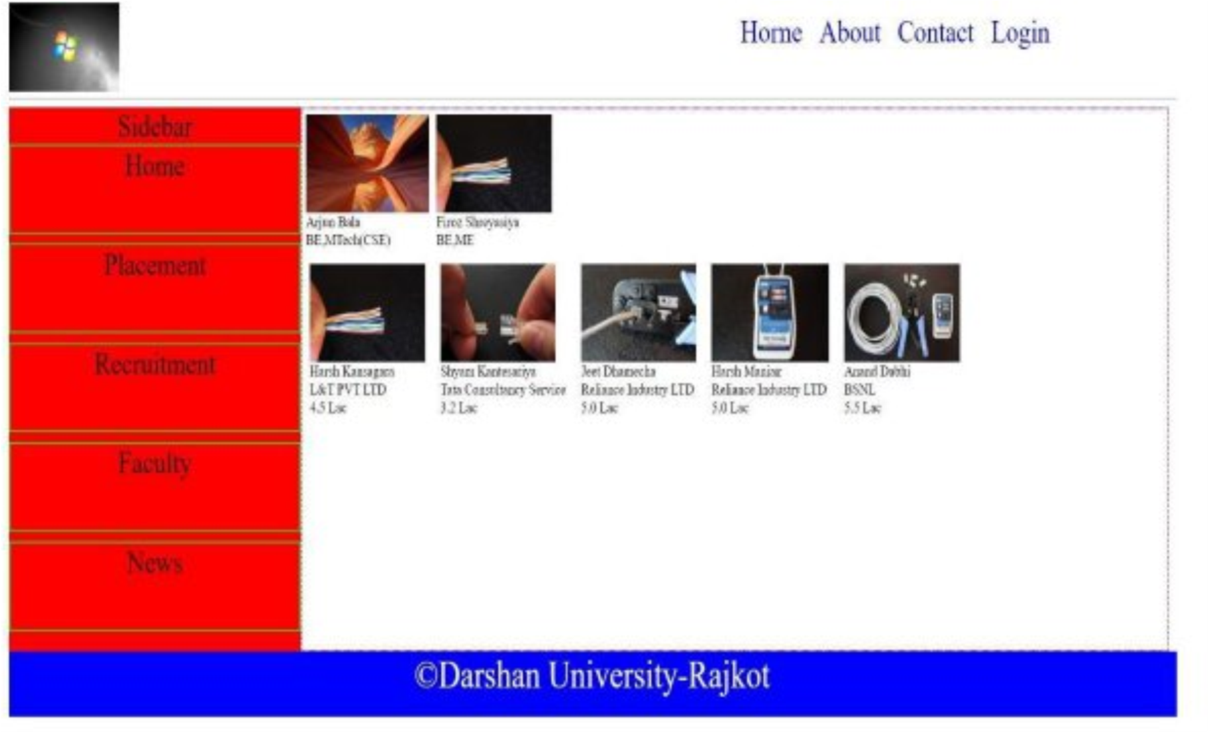

**18**

|  |  |
| --- | --- |
|  |  |
| **19)** |  |
|  |  |